Part 1: ODBC Data Source Set Up(MS Access File must be in the root folder of the web app)

Part 2: Run Data Migration App

1. ODBC Data Source Set Up:

Go to Administrative Tools/ODBC Data Sources (32-bit):

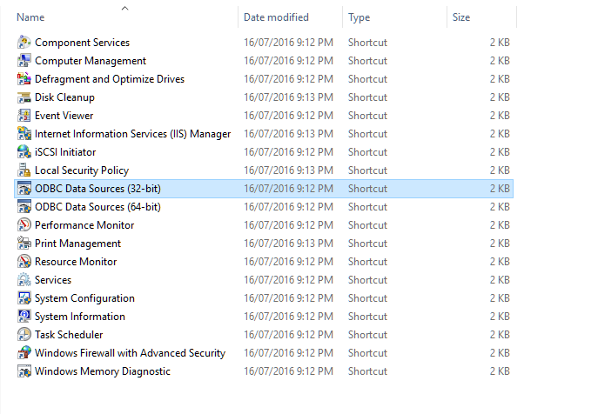

Click Add button on System DSN tab:

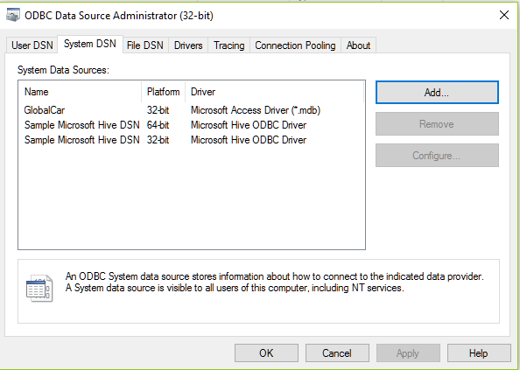

On Create New Data Source Dialog: Select Microsoft Access Driver (*mdb, *.accdb) then click Finish button:

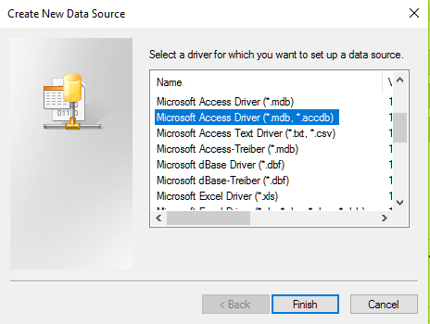

The ODBC Microsoft Access Setup Dialog appears, enter Data Source Name(For example: sps_access_db) then click on Select button in Database group:

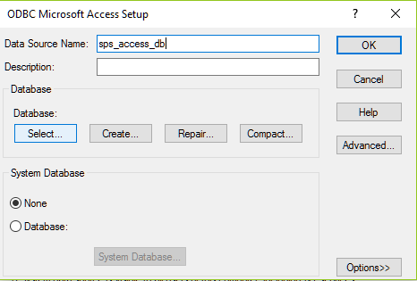

Select Ms Access File then click OK:

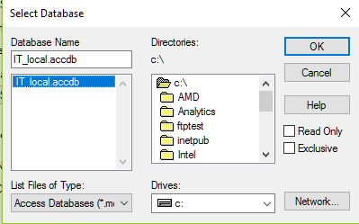

Click OK button on ODBC Microsoft Access Setup Dialog.

The Data Source Name should appear on System Data Sources:

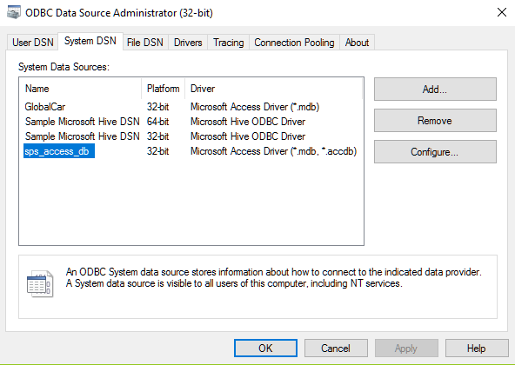

Click OK button to finish.

1. Run Data Migration App:

* Start the App:

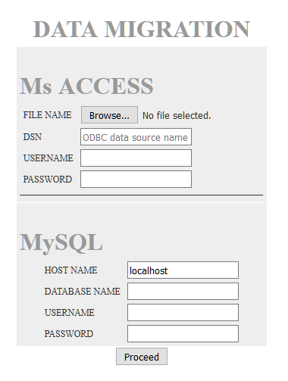

* Click Browse button to select Ms Access file(here is IT_local.accdb):

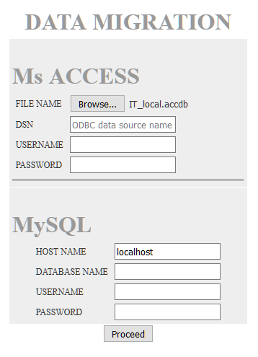

* Enter data source name which is set up in Part 1(here is sps_access_db)
* Enter MySQL Server host name(here is local machine)
* Enter any desired database name(for example sps_for_testing)
* Enter MySQL username and password
* Click Proceed button to convert Ms Access(IT_local.accdb) to MySQL database(sps_for_testing).

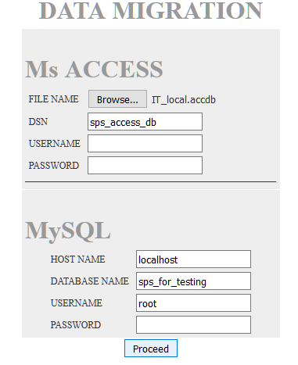

* Done.